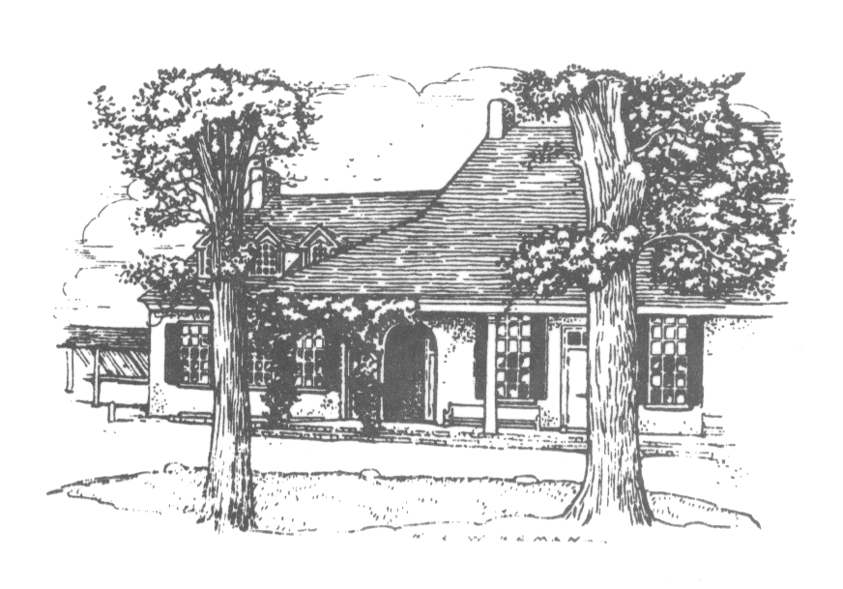
Join us for…

The Green Street Messenger

Green Street Messenger
monthly calendar & newsletter o
Green Street Monthly Meeting of Friends
45 West School House Lane
Philadelphia, PA 19144
West Philadelphia Preparative Friends Meeting
1018 S 48th St (Squirrel Hill Apartment Bld.
Basement)
Philadelphia, PA 19143

First Day Meeting for Worship 10:30 am
First Day School 10:30–11:15 am
First Day Meeting for Worship at West Phila. Mtg. 1:30 pm
Wednesday morning Meeting for Worship 8:30–9:00 am with GSFS
First Sunday evening Meeting for Worship 6:30–7:00 pm at Stapeley Hall
267-285-0553 / secretary@greenstreetfriendsmeeting.org Office hours: 9:45–12:45 Mon.–Fri.
For updates and more information: go to greenstreetfriendsmeeting.org

June 2017

Sunday, 4th 9:30 am Breakfast with a Friend—Bob Dockhorn
Rise of Meeting Coffee Hour—Sandra Rodriguez
12:30 Care & Counsel Committee Meeting

Saturday, 10th 6:00 pm Documentaries and Discussion Series: Hidden Figures (Here at GSMM. Please see the About F/friends section)
Note change to second Saturday

Sunday, 11th 9:00 am Called Meeting for Business
(Please see the About F/friends section)
Rise of Meeting Coffee Hour—Peggy Worthington/Sheldon Berman

Sunday, 18th Rise of Meeting Lunch—Blythe/Eric Davenport
12:45 Meeting for business

Sunday, 25th 9:15 am Friendly Bible Study
Rise of Meeting Coffee hour—Susan Christian



Minutes of Monthly Meeting for Business Held Fifth Month 21, 2017
At Green Street Monthly Meeting of the Religious Society of Friends, held at 45 West School House Lane, Philadelphia, Pennsylvania, on Fifth Month 21, 2017: Business Meeting convened at 12:30 pm in prayerful silence.

17-05-01 The clerk welcomed Friends, thanking them for attending the meeting.

17-05-02 Friends reviewed and assented to the agenda.

17-05-03 Minute of Appreciation for the Annual Barbecue
Friends expressed their gratitude for the amazing barbecue lunch provided before business meeting by Gabbreell James, Kenyatta James, Cheryl McFadden and assistant Friends. Friends listed dishes for which they were particularly thankful, including the marinated pork, the sweet potatoes, and the veggie skewers. Thanks were also given for the fish, as well as the fact that there were many vegetarian options. We look forward to next year.

17-05-04 Rug Committee
JoAnn Seaver read Sharon Mullally’s report. The Committee has received two additional estimates on the rug replacement. One promising estimate was from a company that recycles our old carpet, and which would use a remnant to carpet the meeting room. Currently the only sample they have is a gray color with a white pattern. The other estimate was from Reinhardt’s. The Committee will make further decisions in June.

JoAnn asked Friends to let Sharon know any suggestions, and the Meeting encourages the Committee to continue their good work, but not to wait until the end of the summer. Friends also remind the Committee that the meeting room is also used by the School, and we trust that the committee is considering a color and style that will be acceptable to the School community in addition to the Meeting. A Friend asked that the Committee consider the possibility of environmental concerns including VOCs or rugs that might trigger allergies. Friends would like to see the picture of the sample.

The Committee is released to continue their work and make the final decision.

17-05-05 Property Committee
Dan McDevitt and Larry McEwan reported on the plans for the kitchen renovation. The group has made good progress and is at the midpoint in the design. The hope is to have a final design by June which we can use to get bids.

Larry reported on fruitful meetings that he has had with Gabbreell James and Margie Felton from the Meeting, as well as members of the School community. These meetings have given good feedback, which he has used in his design. In addition, the firm has met with a consultant from Singer Equipment to discuss the exhaust system options, and those plans have been reviewed and were met positively by the historical commission. Finally, Larry explained the current idea about how to install accessible ramps for the dining room and other parts of the school campus. This plan addresses some of the current concerns about safe fire egress for the dining room.

The next steps include plans for managing acoustics in the dining room and planning for listening assistance in the meeting room. For the kitchen, a discussion will take place about specifics on the cabinets and counters in order to get a cost estimate. Larry recommends that we ask Singer to start to fabricate those components as we go through the bid process, so that once we have made a decision on general contractor, these parts will be built and ready to install. Once the design phase is done, the architects will produce drawings and start the application process for permits from the city. The bidding process can take place concurrently with the application period.

Friends asked clarifying and detailed questions, which Larry responded to with the current plans and considerations. Many of the concerns will be addressed as the design is finalized.

The Clerk expressed gratitude to Larry and Dan for their work and for coming to report to business meeting again. The meeting hopes to have further information and to be engaged in the bidding process by the Sixth month business meeting. Worship and Ministry is responsible for arranging our summer meeting hosting with Germantown Friends Meeting.

Traci Hjelt Sullivan reported on behalf of the Trustees; they are confident that the Meeting is fully able to fund this project. Friends are thankful and happy to finally be making the building accessible.

17-05-06 Nominating Committee
Walter Hjelt Sullivan reported.

He presented the School’s Board of Trustees report.
Four people are departing the Board and four people are renewing for a new three-year term. There are no new members coming on to the board. The meeting approves the renewing members.
School’s Board of Trustees: Renewals for June 2017 to June 2020:
Megan Kafer
Chip Linehan
Jen Kolker
Anne Bayless (Clerk)

Rotating off:
David Moos
Frank Zadlo
Robert Dockhorn
Melody Regino

Walter reported that the Governance Committee would like to change the process of renewing Board members. The new process would entail providing a report on renewing members to the Meeting for acceptance. The Meeting does not support this change and will continue to approve the names of members who are renewing their terms.

The Committee brought a first reading of new nominations as well as the names of those rotating off:
Care and Counsel
Bill van Stone - June 2017 to June 2020
Cheryl McFadden - June 2017 to June 2020
Doris Clinkscale - rotating off

Worship and Ministry
Traci Hjelt Sullivan - June 2017 to June 2019
Don Weightman - June 2017 to June 2020
Valerie Anderson July 2017 to June 2020 (not sure why it says July)
Sharon Mullally - June 2017 to June 2020
Walter Hjelt Sullivan - rotating off

Children and Youth Education:
Chris Mohr (clerk) June 2017 to June 2020
JoAnn Seaver - same term
Anthony DiGiovanni - same term
Andy Jickling - same term
Kathy Angell - same term

Rotating off:
Neal Fordham
Amy Verstappen
Shani Taylor

QVS Support Committee:
Anthony DiGiovanni - rotating off

West Philadelphia Preparative Meeting Joint Care Committee
Don Weightman - June 2017 to June 2020
Paul Dexter - becoming Clerk
Walter Hjelt Sullivan - rotating off

Nominating Committee, rotating off:
Doris Clinkscale
Kenyatta James

These names will be held over for a month. The Committee will bring another round of names for first reading in June.

Walter noted that Neal Fordham, Amy Verstappen and Shani Taylor have carried a great deal of weight on the Children and Youth Religious Education Committee for many years.

Also, the clerkship of the West Philadelphia Preparative Meeting Joint Care Comm. will be passing on to a member of WPPM.

17-05-07 Announcement regarding the Meeting Secretary
JoAnn Seaver reported. Our current secretary will finish her time as our secretary on September 30, 2017. We would like to create a certificate of acknowledgment and gratitude for Gail’s 11 years of service. It will be printed and signed and is to be presented to Gail in September.

The Nominating Committee has been asked to think about a hiring committee and future supervisory committee. The Committee has started to talk about the visioning of the process and new position, and welcomes suggestions from the Meeting.

17-05-08 Report from Quarterly Sessions
Our Clerk had to leave and Anthony DiGiovanni stepped in as Assistant Clerk.

Anthony read the action minute from Quarterly Meeting business session, and recounted some of the discussion and events that took place during the meeting. The Quarterly session agenda had been to look at the minutes of concern from Central Philadelphia MM, Green Street MM, and Philadelphia YM Young Adult Friends, and that was not accomplished.

Friends held a long conversation about the Quarterly Meeting events and our continuing concerns with the leadership of Philadelphia Yearly Meeting and their actions. GSMM will hold a called business meeting on June 11th to continue this discussion. Details will be announced about the time.

We urge Friends to attend our called meeting as well as the called meeting of PhYM on Saturday, June 24th from 10 – 3.

17-05-09 These minutes were approved.

17-05-10 Friends ended in worship.

Meeting adjourned, agreeing to meet again at the appointed time on Sixth Month 18, 2017.

JoAnn Seaver, Clerk
Anthony DiGiovanni, Assistant Clerk
Blythe Davenport, Recording Clerk

Members present: Mina Baisch, Blythe Davenport, Anthony DiGiovanni, Jim Dragoni, Victoria Greene, Gabbreell James, Dan McDevitt. Chris Mohr, Robin Mohr, Frank Perch, JoAnn Seaver, Walter Hjelt Sullivan, Traci Hjelt Sullivan, William Van Stone, Margaret Walters.

Attender: Mary Joy Benson

Guest: Larry McEwen, Architect

Staff: Gail Woodbury, Secretary

About our F/friends
(News and announcements of concern to the Meeting)

Meeting for Worship at Stapeley on the first Sunday of the month.
Stapeley residents will happily welcome anyone who wants to join them in their meeting for worship at 6:30.

SECOND Saturday, June 10, Documentaries and Discussion Series, 6:00 pm: Hidden Figures
Hidden Figures is the incredible untold story of Katherine G. Johnson (Taraji P. Henson), Dorothy Vaughan (Octavia Spencer) and Mary Jackson (Janelle Monáe)-brilliant African-American women working at NASA, who served as the brains behind one of the greatest operations in history: the launch of astronaut John Glenn into orbit, a stunning achievement that restored the nation's confidence, turned around the Space Race, and galvanized the world. The visionary trio crossed all gender and race lines to inspire generations to dream big. This event will be held at Green Street Monthly Meeting at 6:00 pm. Free childcare, refreshments and parking are available. The event itself is also free.
Note change to second Saturday

Sunday, June 11, 9:00 am, Called Meeting for Business
In order to prepare for the called session of the Yearly Meeting on June 24, Friends have felt a need to have a called meeting for business to discuss the issues of race and racism within the yearly meeting. More information will be coming soon.

June 24, Called Session of Philadelphia Yearly Meeting at Arch Street Meeting House
On June 24, a Called Session will be held in response to our conflicts surrounding racism and recent staffing changes. The plan for the day is in development, and the intention of this called session is to make space to listen for God in our midst and listen to one another fully as we labor together. Everyone is invited, and we hope that each meeting will send at least one person, but as many Friends as possible, so that our whole community is included in this important work.

The Called Session will be at Arch Street Meetinghouse, 10 am to 2 pm Saturday, June 24. Please bring a brown bag lunch. Snacks, drinks and childcare for children infant - middle school age will be provided. Info & registration: www.pym.org/event/pym-called-session
(Please RSVP by June 16 if you need childcare so that we can provide adequate support.)
Share what’s happening at Green Street Meeting.
The Website Working Group is looking for photographs (with captions), descriptions of Meeting events, and short opinion pieces. We are happy to help with editing. Please submit to geniverm@yahoo.com. Items that you would like added to the Google calendar on our website should be submitted to the Meeting secretary at secretary@greenstreetfriendsmeeting.org.

[[[[[[[[[[[[

The Sixth Query on Equality
How does our Meeting help to create and maintain a society whose institutions recognize and do away with the inequities rooted in patterns of prejudice and economic convenience?
Is our Meeting open to all regardless of race, ability, sexual orientation, or class?
What steps are we taking as a Meeting to assure that our Meeting and the committees and institutions under our care reflect our respect for all and are free from practices rooted in prejudice?
Do I examine myself for aspects of prejudice that may be buried, including beliefs that seem to justify biases based on race, gender, sexual orientation, disability, class, and feelings of inferiority or superiority?
What am I doing to help overcome the contemporary effects of past and present oppression?
Am I teaching my children, and do I show through my way of living, that love of God includes affirming the equality of people, treating others with dignity and respect, and seeking to recognize and address that of God within every person?

[[[[[[[[[[[[

Contact information and Events for major Quaker Organizations
American Friends Service Committee | Quaker values in action https://www.afsc.org/
Friends Committee on National Legislation https://www.fcnl.org/
Friends General Conference | Nurturing faith and Quaker practice www.fgcquaker.org/
Friends Journal: A Quaker magazine to connect and deepen spiritual ...www.friendsjournal.org/
Friends World Committee for Consultation Section of the Americas ...fwccamericas.org/
Philadelphia Yearly Meeting - Home www.pym.org
Called Session on June 24. Please see the About F/friends Section or go on-line
Annual Sessions 2017, Faith Magnified
July 26- 30, The College of New Jersey Ewing, NJ
Details: www.pym.org/annual-sessions

News and Announcements
Workshops and/or Short Courses at Pendle Hill
The Pendle Hill website now lists one day events, weekends and weeklong events. Please call Pendle Hill at (610) 566-4507 or (800) 742-3150, ext. 3, or go to pendlehill.org. Matching scholarships are available; please call. For more information, please go to their website, pendlehill.org, or call.
Saturday, June 3. 6-7 pm Pendle Hill A Shout Out for Effective Political Advocacy (YAF Advocacy Event)
June 19-23, Quakers in the World, but Not of It: Faith and Citizenship Yesterday and Today
Extended Meeting for Worship Saturday, June 3, Chester Friends Meeting
Details: Lola Georg, lolageorg@gmail.com or
www.pym.org/event/2017-extended-meeting-for-worship-jun-3/?instance_id=319

Tuesday, June 6: Moscow Friend Speaking at Germantown Friends School
On Sunday Jun 6, at 7 pm, in the Hargroves building of Germantown Friends School, Julie Harlow will speak on the “Current Conditions in Russia and the Work of Friends in the Region.” Julie Harlow began working toward the fulfillment of the vision of a Quaker presence in Russia immediately after the collapse of the USSR in 1991. Active with the international governing board of Friends House Moscow since its inception, and currently the Clerk, she can share the challenges, disappointments and successes from its beginnings up to the current program. Free and open to the public. For information, contact Joanne Sharpless at jsharpless@germantownfriends.org. She is also speaking at Swarthmore Meeting on June 7. Below is the information link.
Details: www.pym.org/event/friends-house-moscow-current-conditions-russia-work-friends-region-julie-harlow/?instance_id=845

Humor Corner: Zen Koans for the Internet Age
If an anonymous comment goes unread, is it still irritating?
What is the sound of no hands texting?
If nobody likes your selfie, what is the value of the self?

Quote Corner: “When I despair, I remember that all through history the way of truth and love have always won. There have been tyrants and murderers, and for a time, they can seem invincible, but in the end, they always fall. Think of it -- always.” ― Mahatma Gandhi
(Found in the Central Philadelphia MM weekly bulletin for Jan. 22, 2017.)

The submission deadline for the July/August newsletter is 9:30 am on Friday, June 16.

